**Guidelines for Data Visualization and Analysis Project**

**Contribution - Individual**

**GitHub Link -** [**https://github.com/Vigneshwaran-Vicky/Data-Visualization-and-Analysis-Project-Using-Tableau/tree/main**](https://github.com/Vigneshwaran-Vicky/Data-Visualization-and-Analysis-Project-Using-Tableau/tree/main)

**About the Project:**

In this project, you will be working with a dataset from the Superstore, aiming to answer 30 scenario-based questions through data visualization and analysis. Your objective is to select the best chart for each question and explain your choice. This project will showcase your proficiency in data visualization, critical thinking, and effective communication.

**Skills Required:**

* Proficiency in data visualization concepts and techniques.
* Familiarity with Tableau or a similar data visualization tool.
* Strong analytical and problem-solving skills.
* Ability to choose appropriate charts based on data characteristics and question requirements.
* Clear and concise communication skills.

**Deliverables:**

* A Google document containing solutions to the scenario-based questions including the screenshot of the relevant chart picked for each scenario, presented in a concise and well-structured format. Make sure to provide explanations that highlight your problem-solving skills.

**Rubrics for Assessment:**

Question Responses:

* Accuracy and completeness of answers for all 30 questions.
* Clear and concise explanations that address the question's context.

Chart Selection and Explanation:

* Thoughtful rationale for choosing specific chart types.
* Justification based on data characteristics, context, and communication goals.

Creative Enhancements:

* Effective use of creative elements to enhance visualization quality.
* Enhancements that contribute to better understanding or engagement.

**Note**:

* Duplicate this document and proceed to write your solutions.
* For each scenario and question, justify the choice of chart type. Explain why it is the best option to visualize the data effectively.
* Attach screenshots of the charts you have created in Tableau for each scenario and question using the Superstore dataset. Label them clearly to match the corresponding questions in the Google Document.
* Submit the duplicated Google Doc file after completion.

Use these guidelines to structure your data visualization and analysis project. Remember to maintain consistency in your responses, explanations, and visualization styles. This project will not only demonstrate your skills but also your ability to effectively communicate complex information through visualizations. Good luck!

**Problem Statement: Choose the Best chart for any 30 scenario-based questions from Superstore Dataset.**

Imagine you are a data enthusiast aiming to excel in data visualization and analysis. In this task, you have been given 30 scenario-based questions derived from the Superstore dataset, and your objective is to provide insightful answers using appropriate charts. For each question, you need to select a chart that best represents the data, explain why you chose that specific chart, and then proceed to build the chosen chart using Tableau.

Your responses should be succinct, organized, and illustrative of your problem-solving capabilities.

**Dataset Link:**

<https://community.tableau.com/s/question/0D54T00000CWeX8SAL/sample-superstore-sales-excelxls>

**Please keep in mind:**

1. **Answer Completion**: Ensure that you furnish answers for all 30 questions and build charts for them.
2. **Encouraged Creativity**: Don't hesitate to employ visuals, creative elements, or any other innovative approaches to enhance the quality of your responses.

By completing this task effectively, you'll not only demonstrate your proficiency in data visualization and analysis but also showcase your ability to effectively communicate complex concepts through both text and charts.

**Good luck!**

**Questions:**

1. Which product categories have the highest total sales in the "Superstore" dataset?

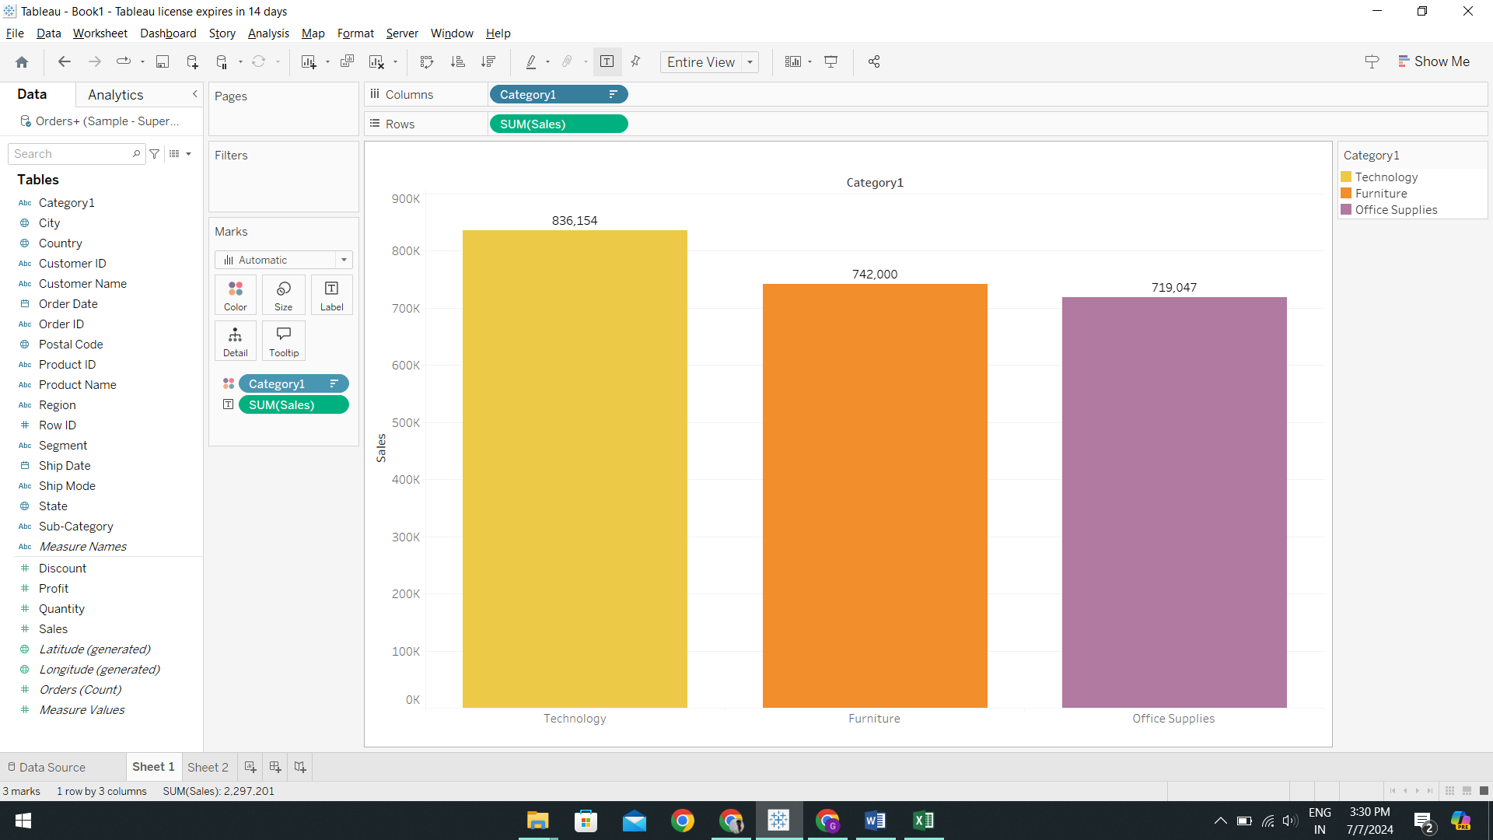

I have chosen to use a bar plot to facilitate easy comprehension and to identify the optimal solutions for our customers. The technology category has the highest total sales, amounting to 836,154, whereas the office supplies category has the lowest total sales, totaling 719,047.

1. How do the monthly sales amounts change over the course of a year?

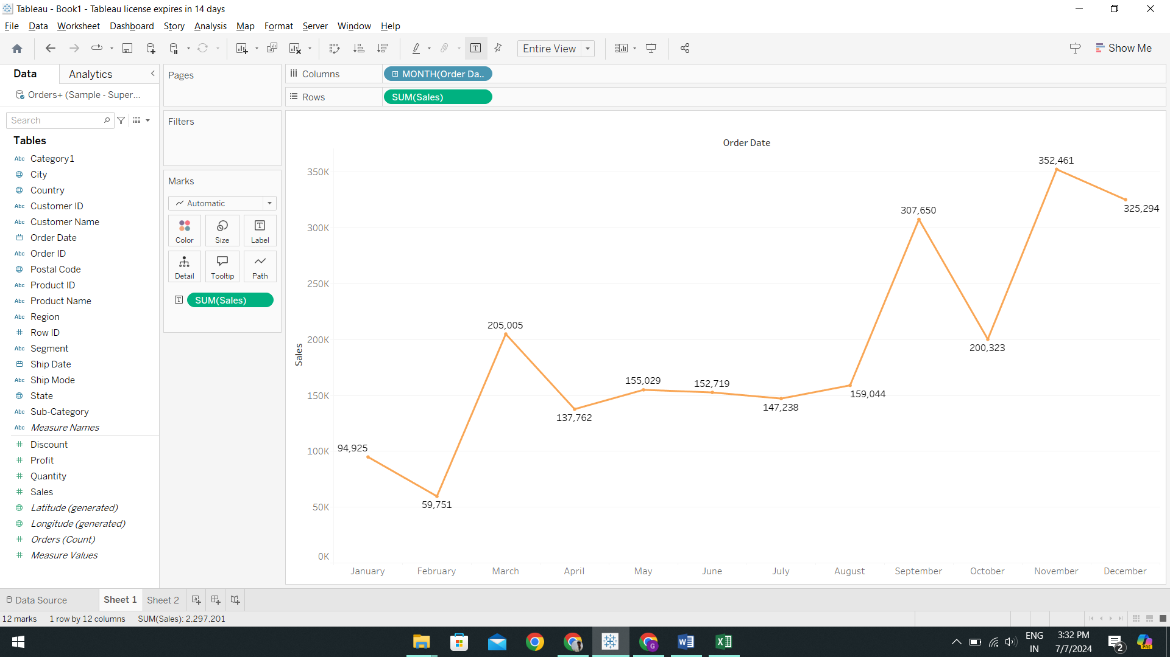

The line chart effectively captures significant fluctuations in the data, making it an ideal visualization for illustrating the monthly variations in sales quantities over a year. It succinctly depicts the sales performance throughout the year, showing a gradual increase from the beginning of the year, reaching a peak in March, followed by a decline during the summer months, and then rising to another peak in September. Towards the end of the year, there is a subsequent decline followed by another upward trend.

This type of graphical representation excels in depicting these temporal changes, offering a visual narrative of periods characterized by high and low sales activity. It underscores the dynamic nature of monthly sales over the course of the year, providing a clear overview of the sales trends throughout different seasons.

1. How is the total sales amount distributed among different product categories?

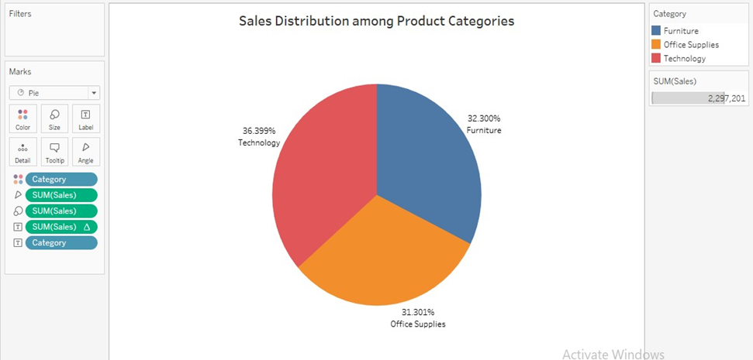

I opted to use a pie chart to visually represent the distribution of total sales amounts across different product categories. This visualization clearly highlights that the "Technology" category commands the highest sales, while "Office Supplies" registers the lowest. The pie chart effectively communicates the proportion of sales contributed by each category to the overall total, providing stakeholders with immediate insight into how sales are distributed among different product categories. This clarity aids in decision-making and resource allocation for the business.

Pie charts serve as valuable visual aids for illustrating the distribution of sales among product categories because they offer an immediate impression of each category's market share relative to the total sales volume. In the depicted chart, "Technology" occupies the largest segment at 36.4%, closely followed by "Office Supplies" at 31.3% and "Furniture" at 32.3%. This visual approach facilitates easy comparison of category sizes, enabling viewers to grasp the relative significance of each segment quickly.

1. Can we analyze the sales performance of individual customers over time?

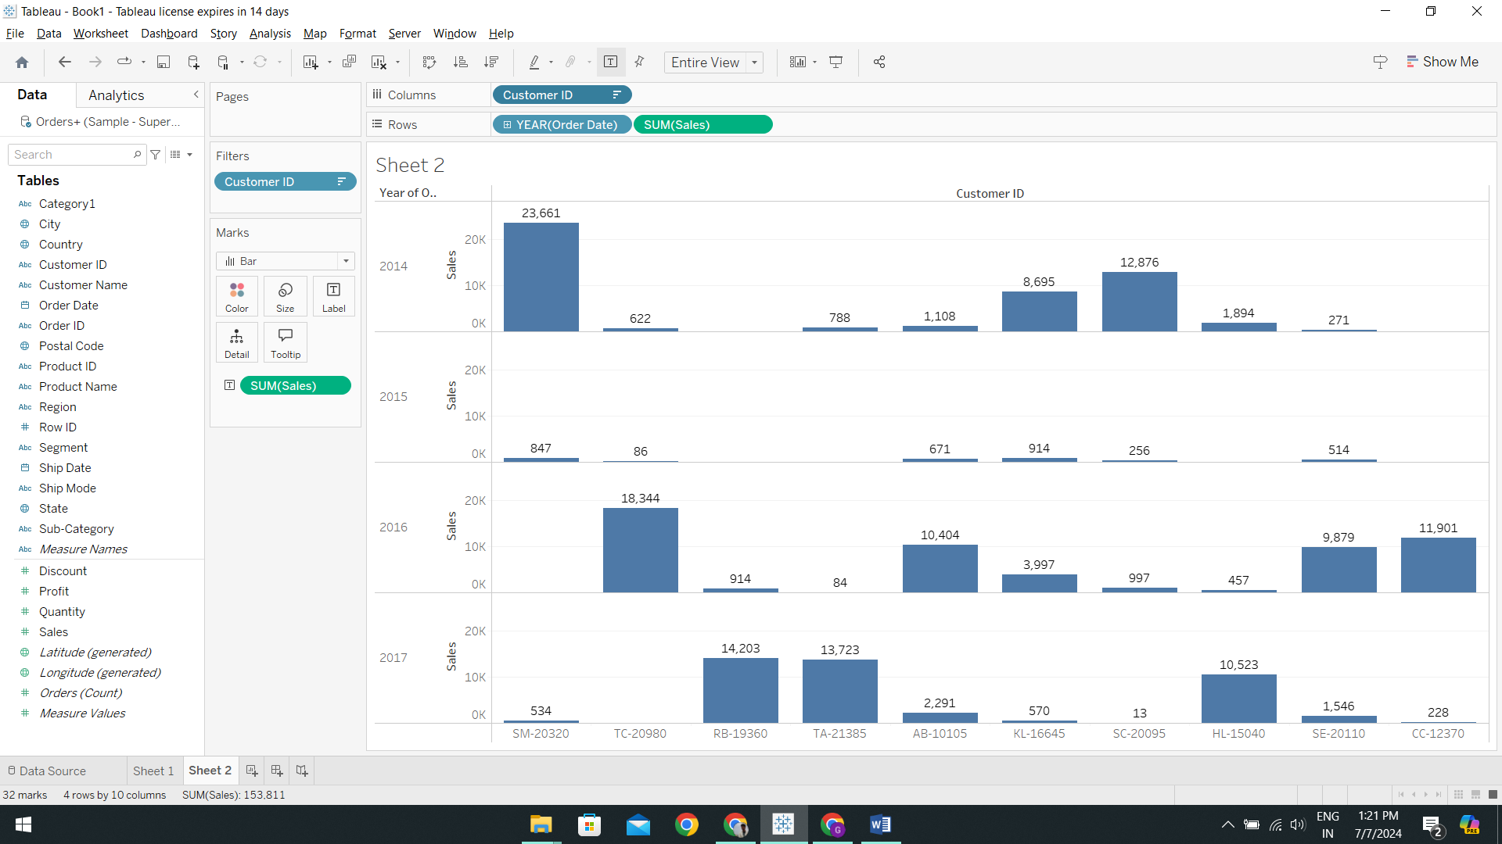

A bar chart is highly advantageous for illustrating sales performance across specific clients, especially when tracking trends over time. Its vertical orientation facilitates straightforward comparisons of sales figures among different clients, offering clear insights into their relative performance.

Enhancing the chart with an interactive feature such as a 'Show Top N' parameter, filtered by 'Customer ID', further enhances its utility. This functionality allows users to dynamically focus on top-performing clients, tailoring the analysis to specific requirements without overwhelming the chart with unnecessary details. This makes the chart not only informative but also highly adaptable to varying analytical needs.

The horizontal bar chart is particularly well-suited for presenting this type of data due to its inherent clarity, readability, and interactive capabilities. It ensures that viewers can easily interpret and compare sales performance across clients, making it an ideal choice for visualizing sales data concisely and effectively.

1. How do sales vary based on different days of the week and product categories?

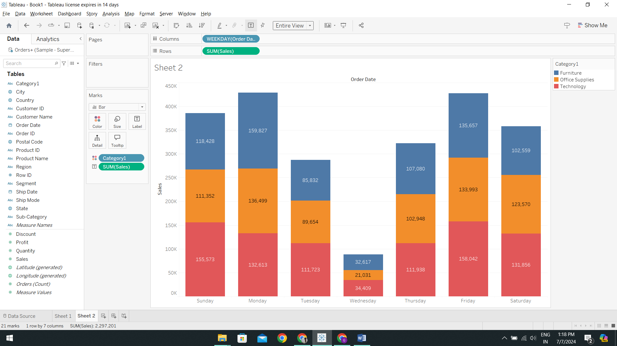

The stacked bar chart proves invaluable for analyzing sales differences across the week and within various product categories simultaneously. This dual-layered approach allows for quick assessments of both overall sales trends and category-specific performances. For instance, it facilitates identifying peak sales days and understanding which product categories dominate on specific days.

Each category is visually distinguished by its unique color, enhancing clarity and easing differentiation between them. The chart indicates that sales were below average on Tuesday, Wednesday, and Thursday, while significantly exceeding average on Monday and Friday.

This type of visualization excels in illustrating how different segments contribute to the total sales both temporally and across categories. It provides a comprehensive view that aids in identifying patterns and making informed decisions based on sales performance data.

1. Can we visualize the sales growth of different product categories over time?

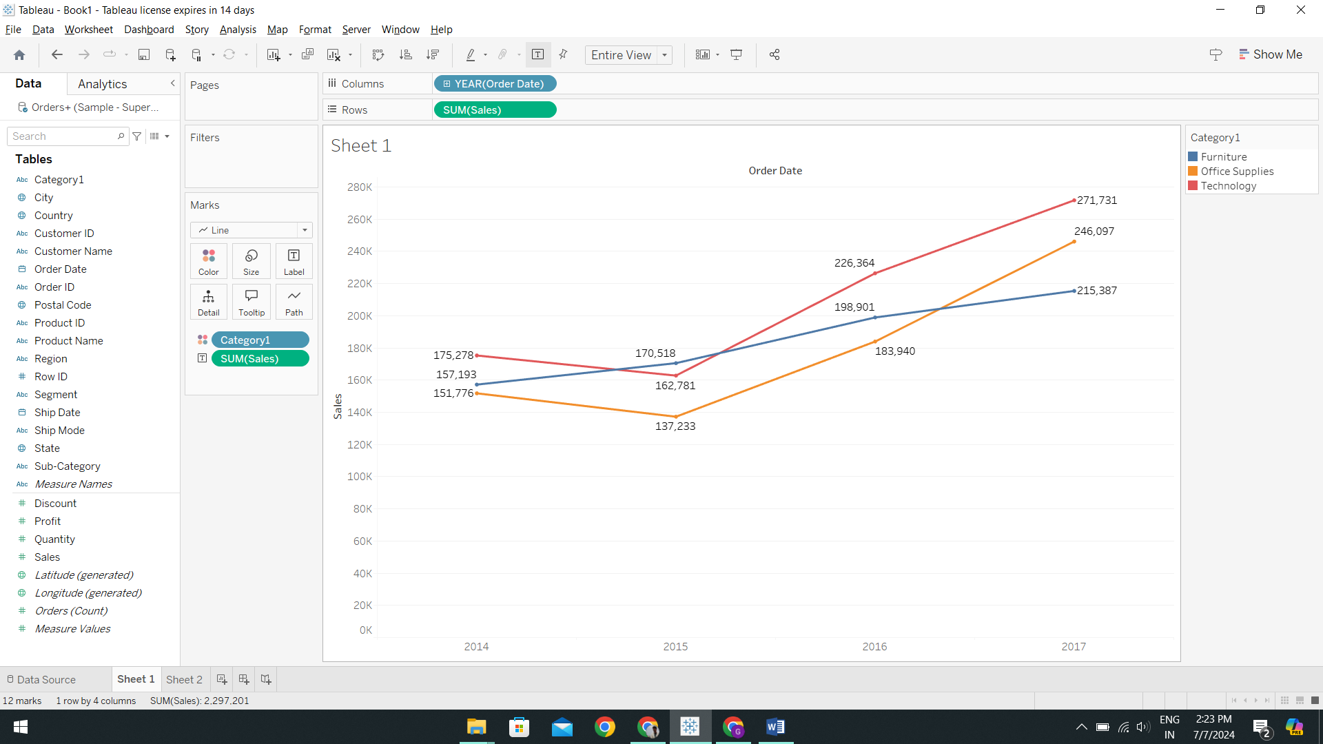

The line chart emerges as the optimal choice for illustrating the sales growth across various product categories over time due to its ability to depict patterns and changes straightforwardly. Each line within the chart represents a distinct product category, offering a visual narrative of how sales have evolved. This makes it particularly effective for analyzing time-series data and understanding the dynamics of sales trends.

The chart reveals a notable upward trend in sales for the technology, office supplies, and furniture categories from 2014 to 2017. Particularly striking is the significant growth in technology sales, especially noticeable from 2016 to 2017, indicating a rising demand in this category. Office supplies demonstrate steady and consistent growth, suggesting stable market demand. However, furniture shows slower growth, suggesting potential areas for strategic improvement to enhance its sales performance.

In summary, the line chart effectively captures the sales growth trajectory of different product categories over time, providing insights into both overall trends and specific category performances. This visualization aids in identifying opportunities for growth and strategic planning based on the observed sales patterns.

1. How does the sales distribution vary across different regions in the "Superstore" dataset?

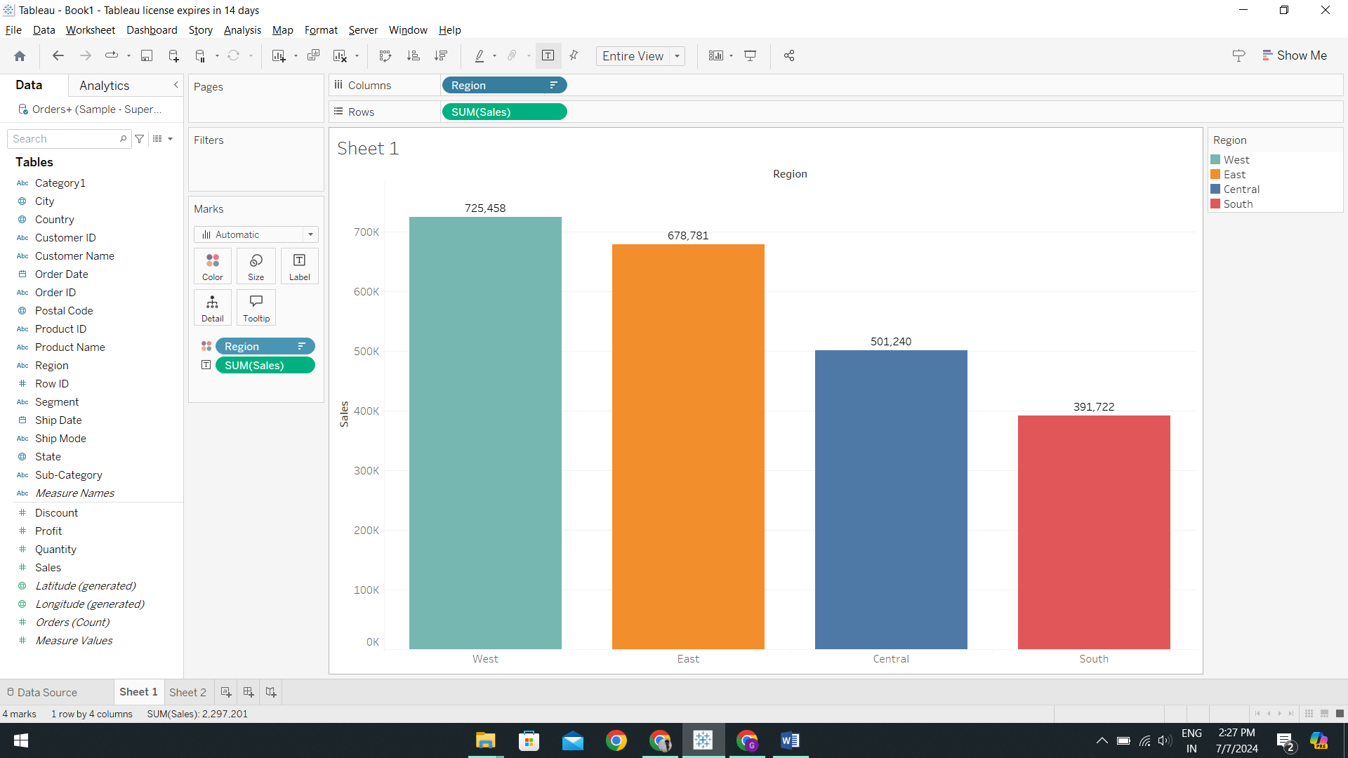

The bar chart's innate simplicity, aligning naturally with how people read text—from top to bottom and left to right—makes it an ideal choice for visualizing sales distribution across different locations. Its ability to display bars in ascending or descending order efficiently communicates the hierarchy of performance among regions based on sales volume.

This type of chart excels in providing a clear and immediate overview of sales distribution, particularly effective for comparing performance across multiple categories. Leading with sales estimated at $725,458, the West region emerges at the top, followed closely by the East with approximately $678,781. The Central region follows with sales nearing $501,240, while the South region reports the lowest sales at around $391,722.

In summary, the bar chart effectively communicates the sales distribution across regions, allowing viewers to easily grasp the relative performance and ranking of each location. Its simplicity and intuitive design make it a powerful tool for visualizing and analyzing regional sales data.

1. Can we visualize the composition of profits across various subcategories within different customer segments?

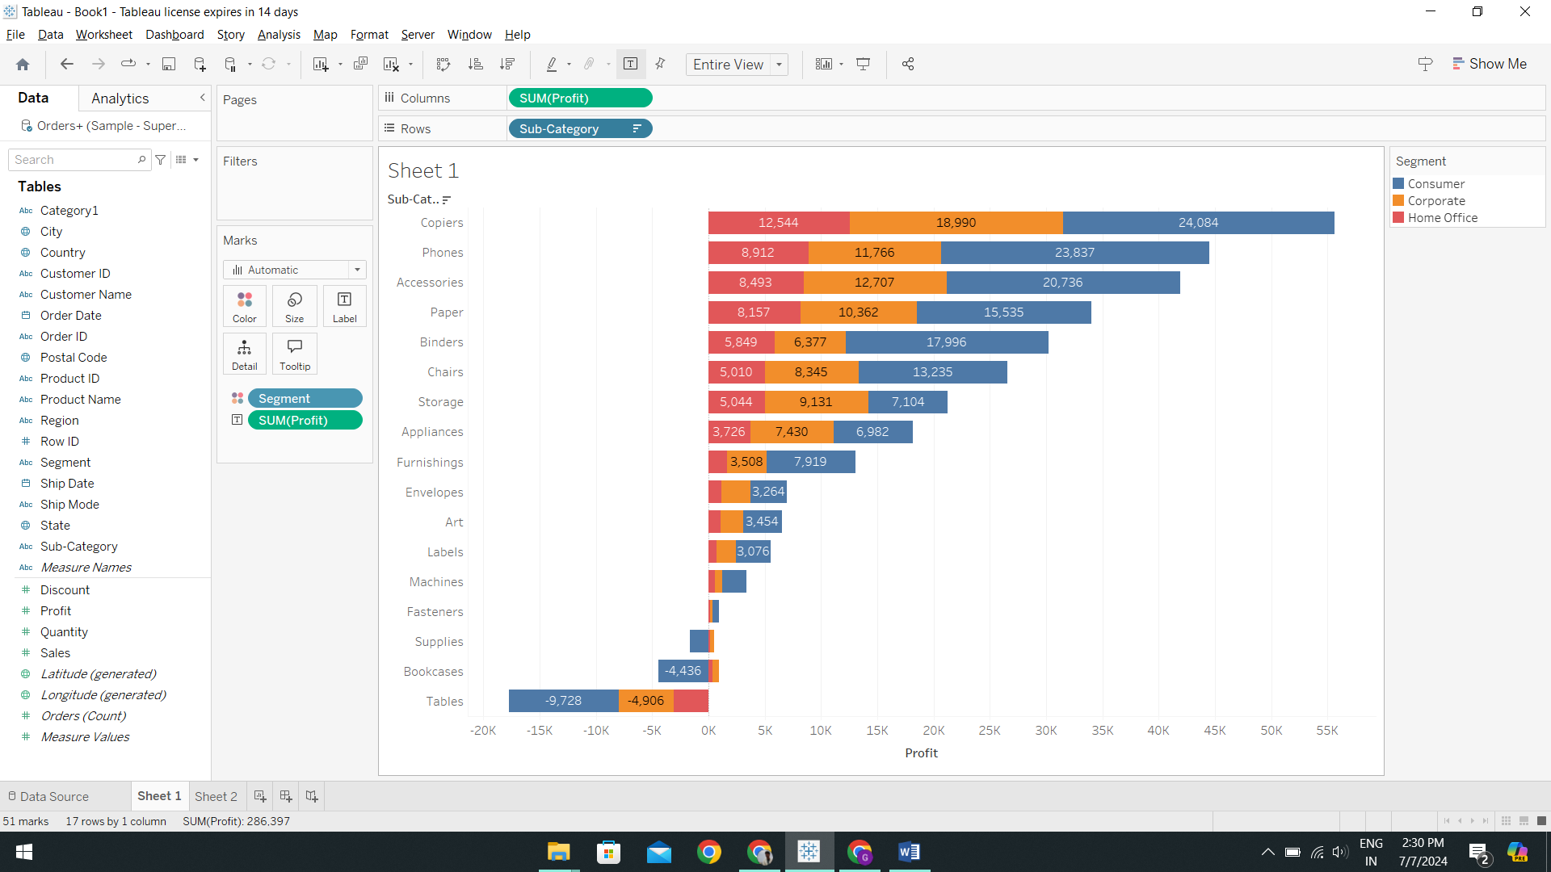

The horizontal stacked bar chart proves invaluable for dissecting and comparing profits across subcategories and client segments, leveraging distinct colors to delineate each customer group. This design facilitates comprehensive analysis by visually presenting both the total profits for each subcategory and the contribution of each segment. Its capability to represent negative values effectively showcases loss-making subcategories with bars extending leftward from the zero line. Additionally, subcategories are ranked by profitability, aiding in swiftly identifying the most and least profitable sectors.

The chart highlights several key insights: "Tables" and "Bookcases" consistently incur losses across all segments, whereas "Copiers" show strong profitability, particularly within the Corporate segment. The Consumer segment exhibits varying profitability, notably with "Phones" and "Accessories" showing significant potential. In contrast, the Home Office category demonstrates robust profits in "Chairs" and "Storage," suggesting a demand for home office furniture. These observations underscore the importance of addressing challenges in underperforming subcategories and exploring tailored marketing strategies to capitalize on profitable segments.

In summary, the horizontal stacked bar chart effectively communicates profit distributions by subcategory and client segment, offering insights that guide strategic decisions aimed at enhancing overall profitability and market responsiveness.

1. What is the percentage contribution of each region to the overall sales?

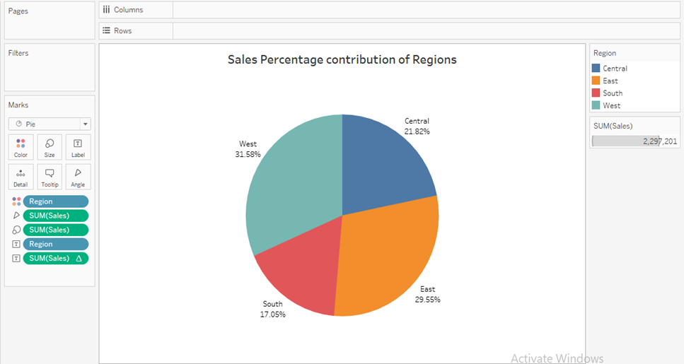

The pie chart is highly effective for illustrating the proportional contribution of each region to total sales due to its innate ability to visually represent proportions. This visualization method swiftly communicates the distribution and dominance of sales across different locations. Additionally, the explicit labeling of percentages enhances clarity, enabling viewers to promptly discern the share of each region.

In the depicted pie chart, the West emerges as the leading region with a contribution of 31.6%, followed closely by the East at 29.5%, the Central at 21.8%, and the South at 17.1%. This visual representation clearly delineates the percentage contributions of each region to the overall sales volume, providing a concise and insightful overview of regional sales performance.

In summary, the pie chart effectively conveys the relative sales contributions of different regions, leveraging visual proportions and labeled percentages to facilitate quick understanding and analysis of regional sales distribution.

1. Can we visualize the profit margins associated with different shipping modes and customer segments?

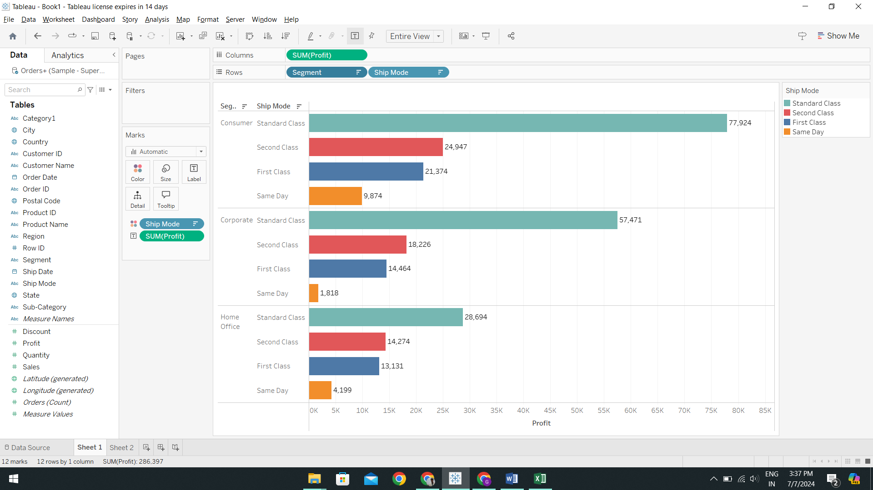

The grouped horizontal bar chart is exceptionally effective for illustrating profit margins across shipping methods within different customer segments. Each shipping mode is represented by distinct colored segments within horizontal bars, enabling clear visualization of their respective contributions to overall revenues. The horizontal layout accommodates lengthy labels and multiple categories without sacrificing readability, enhancing clarity and ease of interpretation.

This graphic clearly indicates that Standard Class shipping yields the highest profit margins across all divisions, particularly prominent within the Consumer segment. Conversely, the Same Day shipment appears least profitable, suggesting potential issues with cost-effectiveness or demand that require attention to optimize profitability.

In summary, the grouped horizontal bar chart provides a comprehensive view of profit margins by shipping method and customer segment, facilitating informed decisions by highlighting profitable trends and areas for improvement.

1. How long does it take to process orders for different product categories?

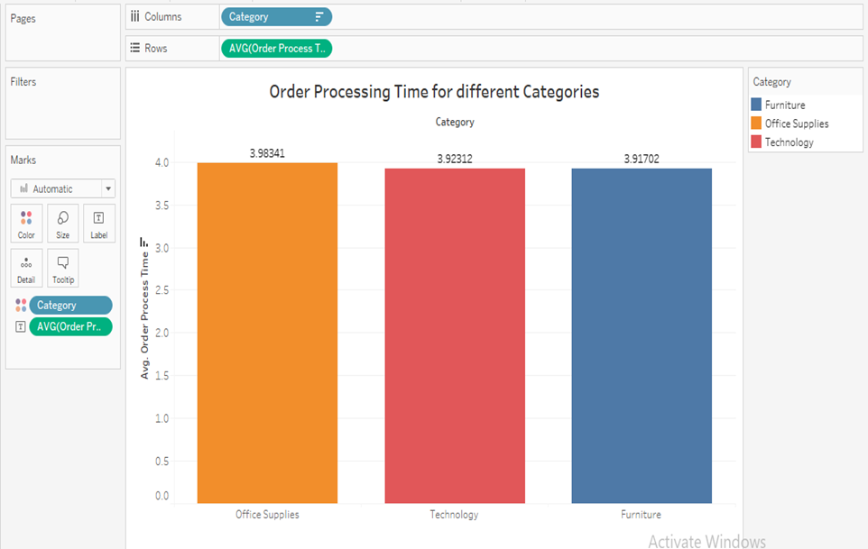

A vertical bar chart proves highly effective for visualizing the average order processing time across different product categories, with each bar's height representing the time from order to shipment. By utilizing the calculated variable 'Order Processing Time'—which measures the days between 'Order Date' and 'Ship Date'—the chart maintains accuracy and relevance to the processing timeframe. This type of visualization facilitates clear comparisons between the Technology, Office Supply, and Furniture categories.

The data indicates that the average shipping times for Furniture, Office Supplies, and Technology are all slightly below four days. This consistency suggests a uniform order processing mechanism across all categories. Notably, Office Supplies exhibit a slightly longer processing time with an average of 3.98 days, compared to 3.92 days for both Furniture and Technology.

In summary, the vertical bar chart effectively communicates the average order processing times for different product categories, highlighting similarities and pinpointing areas, such as Office Supplies, where potential process optimizations could lead to improved efficiency. This visualization aids in understanding and addressing operational efficiencies related to order fulfillment across various product categories.

1. How do discounts affect overall profit?

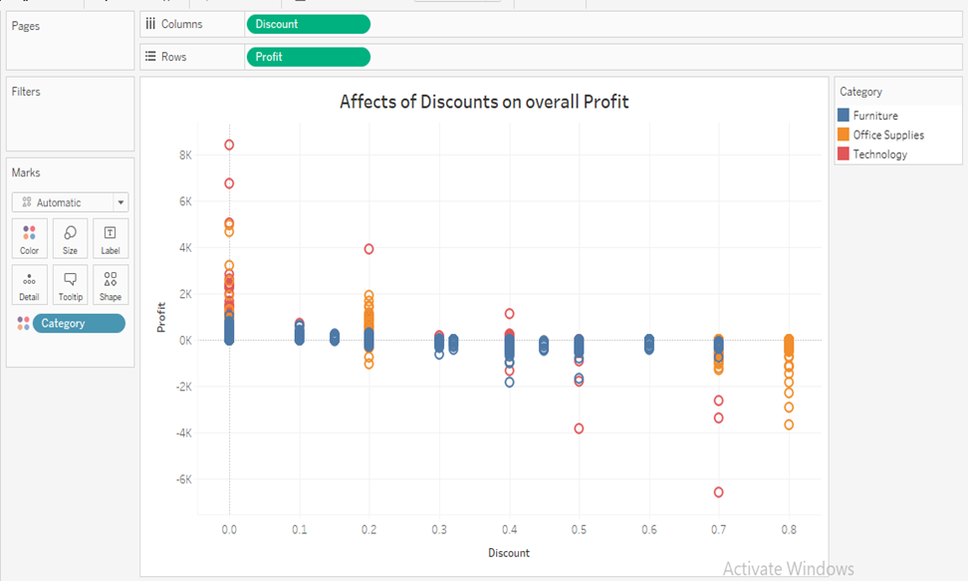

A scatterplot is a powerful tool for visualizing relationships between two quantitative variables, enabling the identification of patterns, trends, and correlations. It effectively illustrates whether changes in one variable correspond to changes in another, making it ideal for analyzing relationships, detecting outliers, and comparing multiple datasets.

In this scenario, the scatterplot compares the variables 'Discount' and 'Profit' across different product categories, using distinct colors to differentiate each category. The spread of points (circles) on the plot indicates how discounts influence profit margins across various categories.

Upon inspection, it is evident that discounts have a significant impact on profit margins for 'Technology' products, as well as for 'Office Supplies', albeit to a lesser extent. In contrast, 'Furniture' shows a more consistent relationship, where discounts maintain a relatively stable impact on profit.

In summary, the scatterplot effectively communicates how discounts affect profit margins across different product categories, highlighting varying degrees of sensitivity to discounts among 'Technology', 'Office Supplies', and 'Furniture'. This visualization aids in understanding the relationship dynamics between discounting strategies and profitability across product lines.

1. Can we visualize the relationship between product sales and profitability for different product categories?

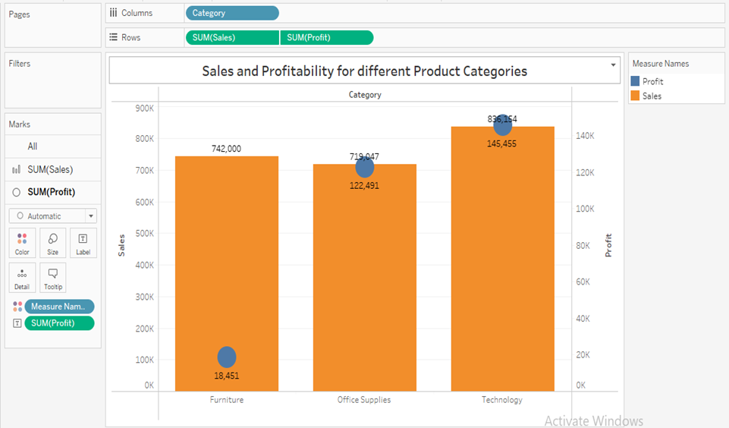

The dual-axis bar chart proves invaluable for illustrating the relationship between sales volume and profitability across product categories by presenting two variables on a single chart. The primary bars depict sales revenue, offering a straightforward comparison of each category's revenue contribution and highlighting those with the greatest impact on overall profitability. Meanwhile, the secondary axis, represented by circles or markers, aligns profitability metrics for easy comparison across categories, illustrating how effectively revenue translates into profit.

Analysis of the chart reveals several key insights: Technology emerges as a top performer in both sales volume and profitability, showcasing strong performance across metrics. Furniture, while boasting high sales volume, exhibits significantly lower profitability, suggesting challenges in converting sales into profit. Office Supplies show a balanced relationship with moderate sales volume and profitability, indicating efficient management of sales and cost structures.

Overall, the dual-axis bar chart effectively communicates the dynamics between sales and profitability across product categories, providing clarity on each category's contribution to overall financial performance. This visualization aids in strategic decision-making by highlighting areas for improvement in profit generation and aligning sales strategies with profitability goals.

1. What is the distribution of order quantities for products in the dataset?

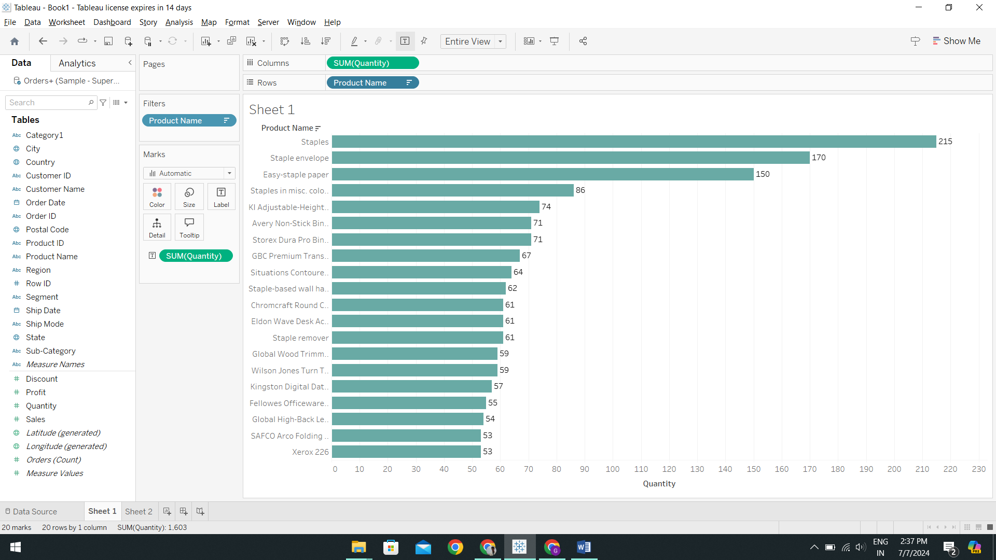

The horizontal bar chart's simple and effective design enhances readability for lengthy product names and facilitates straightforward comparison of data points, making it an ideal choice for visualizing the distribution of order numbers across products. The chart benefits from interactivity, such as the 'Product Quality Range' parameter, which allows for focused analysis of key products, optimizing both space and clarity in interpretation. Its scalability makes it particularly well-suited for handling large datasets.

In the presented chart, the top ordered products include 'Staples', 'Staple Envelopes', and 'Easy-Staple Paper', indicating strong demand and turnover for these items. This visualization underscores the importance of strategic inventory management, especially for high-volume commodities, as it reveals significant variations in order quantities across different products.

Overall, the horizontal bar chart effectively communicates the distribution of order numbers across products, providing insights into product popularity and guiding inventory management decisions to meet demand effectively. Its simplicity and interactive capabilities enhance its utility in analyzing and managing extensive datasets in a clear and concise manner.

1. How do the profit distributions vary across different product categories?

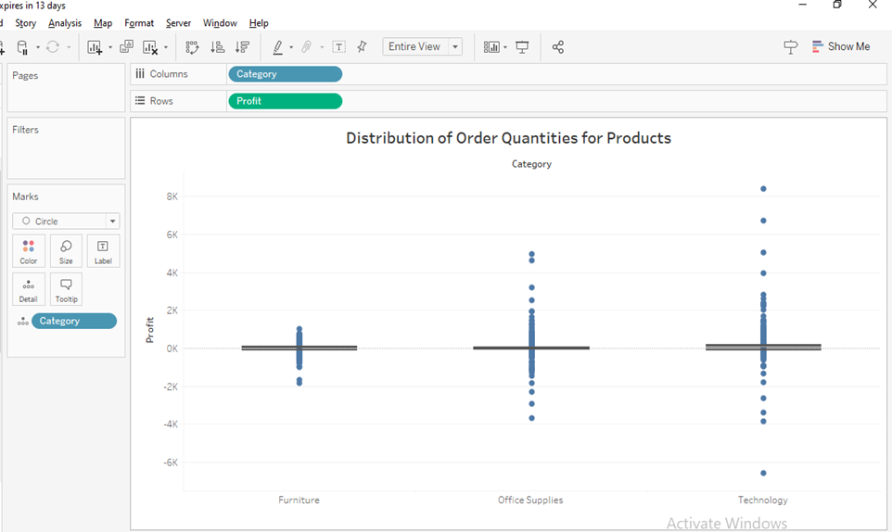

The box-and-whisker plot is an excellent choice for visualizing earnings distributions across multiple product categories, providing a clear depiction of the spread of data through indicators like the interquartile range (IQR) and outliers. This plot effectively highlights the middle 50% of the data (IQR) while also showing the overall range of profits with its 'whiskers', and pinpointing any outliers that fall outside this range.

Examining the characteristics revealed in the box plot for the Technology, Office Supplies, and Furniture categories, distinct profit profiles emerge. Office Supplies demonstrate a narrower range of profits with a median lower than Technology, suggesting a stable but less lucrative market. Furniture shows potential for losses as indicated by outliers below the profit line, indicating variability and possible challenges in profitability. Technology, on the other hand, exhibits a wide range of profits with significant outliers above the profit line, indicating high variability and the potential for substantial gains.

Within each product category, this visualization enables focused strategies for optimizing gains and mitigating losses based on the observed variation in profit distribution. It provides valuable insights into the profitability dynamics of different product categories, guiding strategic decisions aimed at maximizing overall profitability.

In summary, the box-and-whisker plot effectively communicates earnings distributions across product categories, offering insights into profit variability and highlighting areas for strategic focus to enhance financial performance.

1. Can we compare the shipping time distributions for different shipping modes?

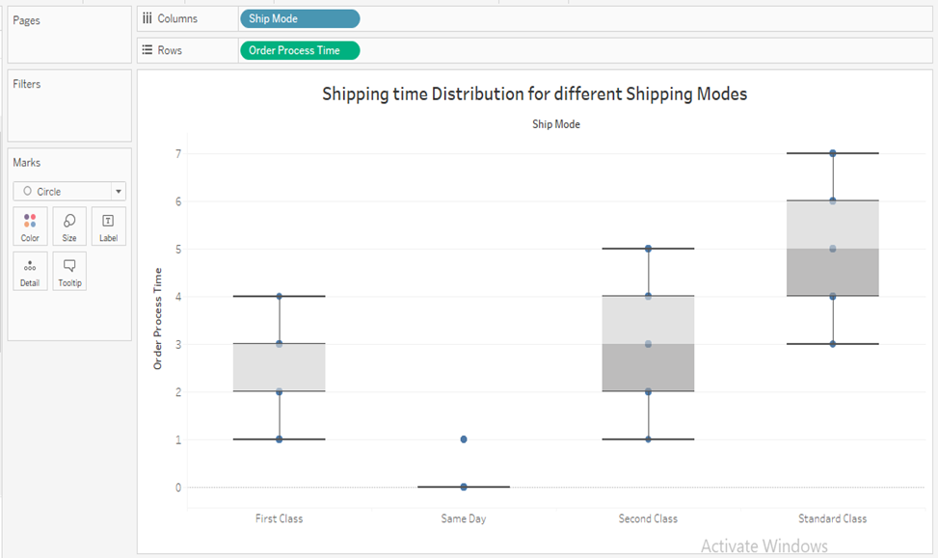

The description provided outlines the characteristics and insights derived from a box-and-whisker plot depicting shipment durations across different shipping classes. Here's a refined summary:

The box-and-whisker plot effectively contrasts regular and outlier shipment durations, providing a comprehensive comparison of shipping time tendencies and their variability. Notably, First Class exhibits a narrow interquartile range, indicating consistent delivery times with a relatively short median shipping duration. Conversely, the Same Day delivery shows the fastest median time, approaching zero, though a negative outlier is likely due to data anomaly.

Second Class displays a wider interquartile range compared to First Class, indicating a broader spectrum of shipping durations and a longer median time, suggesting slower deliveries. Standard Class exhibits the widest interquartile range, reflecting the highest variability in shipment timeframes among the options. It typically records the longest median shipping time, supported by outliers representing both exceptionally fast and delayed deliveries.

In summary, the box-and-whisker plot effectively communicates shipment duration characteristics across different shipping classes, highlighting variations in delivery times and informing decisions related to logistics and service level agreements.

1. What is the monthly trend in the number of orders shipped?

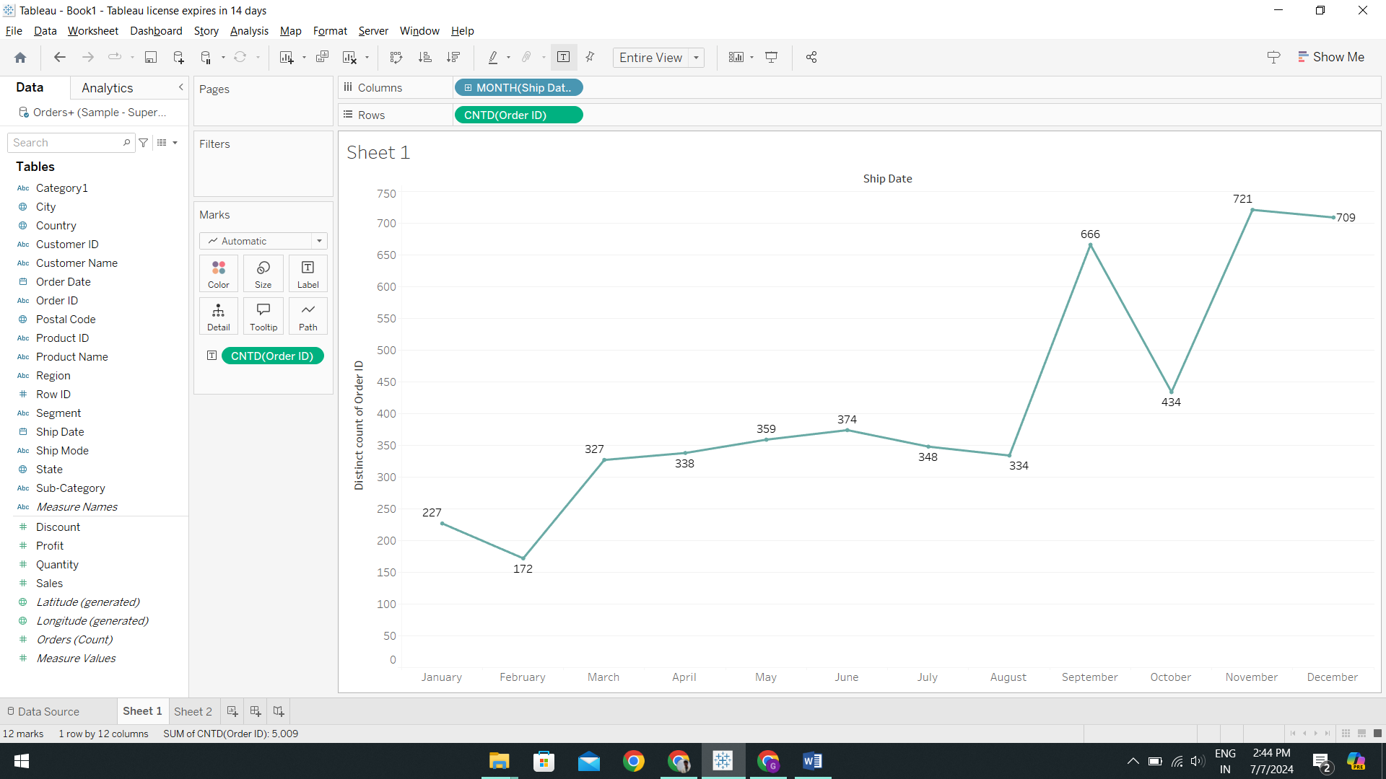

The line chart is an excellent choice for visualizing the monthly trend in the number of orders shipped, effectively illustrating how order volume fluctuates over time. Here’s a refined version of the description:

The line chart clearly depicts the monthly trend in order shipments, revealing distinct patterns throughout the year. The data shows an upward trend in orders from January to March, indicating an increase in shipments at the beginning of the year. February stands out with a noticeable decline, possibly influenced by the month's shorter duration or seasonal market variations. June emerges as the peak month for order shipments, followed by a decline in the summer months, aligning with typical seasonal patterns.

The chart exhibits a significant peak in November, likely attributed to holiday shopping, with a subsequent modest decline in December as the holiday season winds down.

In summary, the line chart effectively communicates the seasonal variations and trends in order shipments over the course of the year, providing insights into peak periods and fluctuations that can inform logistical planning and resource allocation.

1. How do different customer segments perform in terms of sales and discount rates?

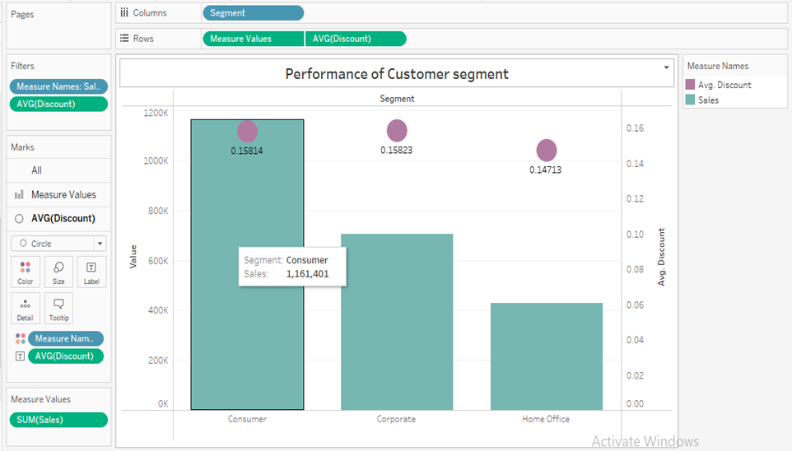

The dual-axis bar chart is a valuable tool for analyzing and comparing sales and discount rates across different consumer segments, as it allows for the simultaneous display of two linked metrics on one graph. Here’s a refined version of the description:

The main bars in the chart represent total sales figures, providing a clear comparison of absolute sales across various customer segments. Superimposed circles or markers on these bars indicate the average discount rates for each segment, contextualizing sales figures by illustrating the discounts applied relative to each segment's sales.

A notable observation is that the Home Office segment deviates from this general pattern by maintaining lower discount rates despite having lower sales volumes. In contrast, the graphic overall suggests a correlation between sales volumes and discount rates, with segments experiencing higher sales volumes typically associated with higher average discounts.

In summary, the dual-axis bar chart effectively communicates the relationship between sales volumes and discount rates across consumer segments, offering insights into how discounting strategies impact sales performance and highlighting variations in discounting practices among different market segments. This visualization aids in strategic decision-making related to pricing, promotions, and customer segmentation.

1. What are the sales and profit trends across different product subcategories and regions in the Superstore dataset?

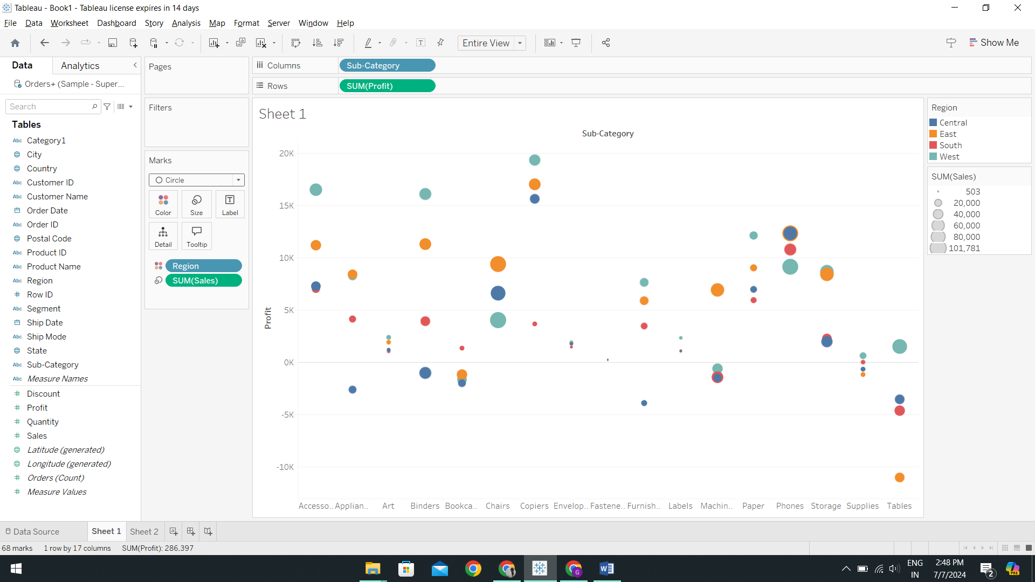

The scatter plot stands out as an excellent choice for visually depicting sales and profit patterns across multiple product subcategories and geographical regions within a single visualization. Here's a refined version of the description:

The scatter plot facilitates multidimensional analysis by presenting sales and profitability data across various product subcategories and geographical areas in a cohesive visual format. Bubble sizes within the chart represent sales volumes, while their positioning on the y-axis provides immediate insights into the profitability of each subcategory within different regions, distinguishing profitable from unprofitable products clearly.

Region-specific color coding enables easy differentiation and comparison of performance across different geographical areas within the same subcategory. The scatter distribution effectively illustrates performance variations between regions, highlighting potential areas for strategic adjustment.

Analysis of the chart reveals several key insights: Phone sales demonstrate strength across all regions, yet carrier profits remain high despite lower sales volumes, indicating larger profit margins. Conversely, consistent losses are evident across all regions for tables, suggesting potential issues with expenses or pricing strategies.

In summary, the scatter plot effectively communicates complex relationships between sales, profitability, product subcategories, and geographical regions. It offers actionable insights for strategic decision-making, guiding adjustments in marketing strategies, pricing, and operational efficiencies based on regional and product-specific performance data.

1. What is the average delivery duration for different regions and ship modes?

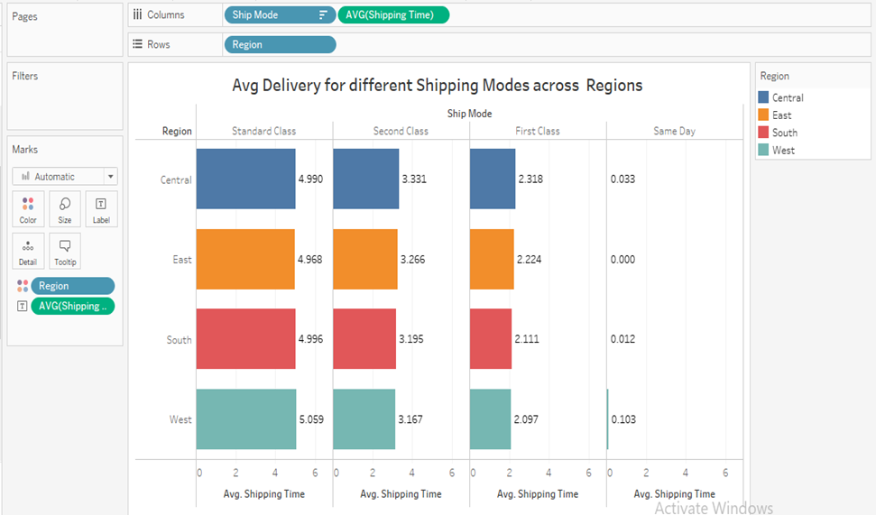

The horizontal bar chart effectively visualizes average delivery times across different locations and shipping modes, utilizing color intensity for clear pattern recognition and comparative analysis. Here’s a refined version of the description:

The horizontal bar chart with its color-coded divisions offers a comprehensive and easily understandable presentation of delivery metrics, facilitating quick insights into average delivery times by location and shipping method. This format is particularly effective for conveying complex data in a clear and accessible manner.

Analysis of the chart reveals distinct trends in delivery efficiency across shipping modes: Same Day emerges as the most efficient option, followed by First Class with average delivery times ranging between 2.09 to 2.31 days. Second Class shows slightly longer average times ranging from 3.16 to 3.33 days, while Standard shipping consistently registers as the slowest option.

Further breakdown by region highlights variations in average delivery times: the Central region generally experiences longer shipping durations, while the East region consistently reports the shortest average delivery times across all shipping methods.

In summary, the horizontal bar chart effectively communicates average delivery times by location and shipping mode, enabling informed decisions regarding logistics and customer expectations. Its visual clarity and comparative analysis capabilities make it an invaluable tool for understanding and optimizing delivery performance across different regions and shipping options.

1. How has the average order quantity changed over the years for various product categories?

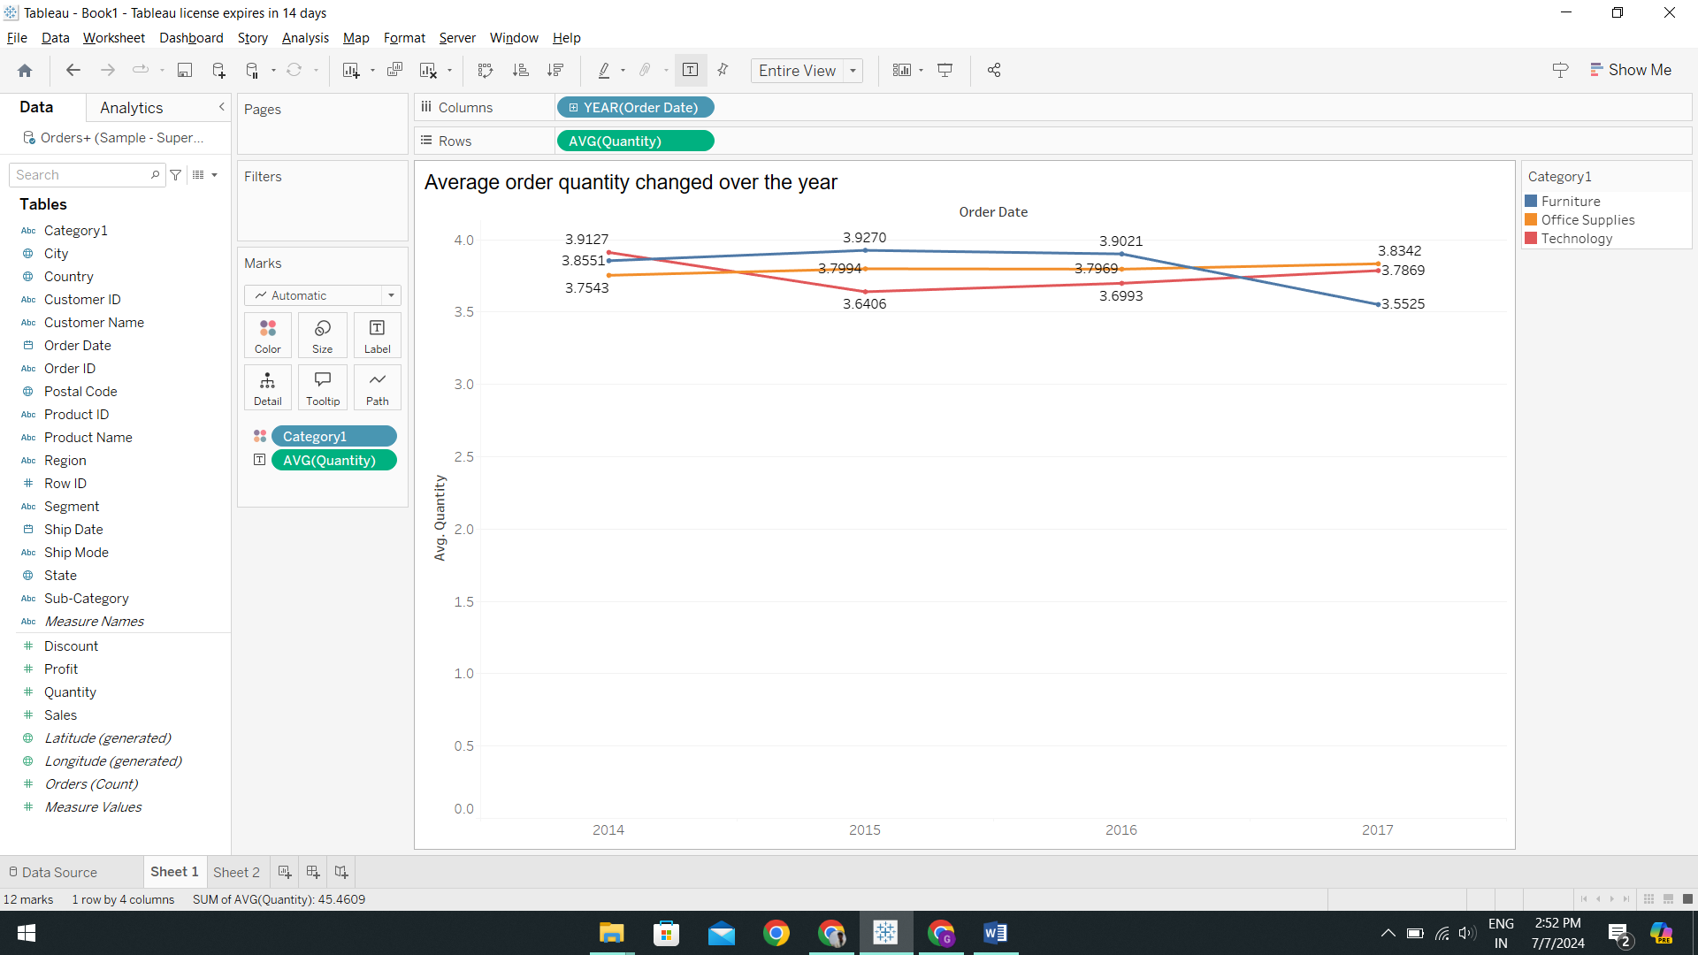

The line chart serves as an effective tool for visualizing the trends in average order quantity over time across different product categories, making comparisons straightforward and patterns evident. Here’s a refined version of the description:

The line chart is well-suited for illustrating the changes in average order quantity over time, providing a clear depiction of trends across several product categories. Its ability to represent continuous quantitative data in a time series format allows for easy identification of increases, decreases, or consistent patterns in the data.

Analysis of the line chart spanning from 2014 to 2017 reveals distinct trends in average order quantity for different product categories:

* Furniture: The average order quantity declined overall during this period, with a peak observed in 2015 followed by a downward trend.
* Office Supplies: Average order quantity exhibited slight overall growth and remained relatively stable over the years.
* Technology: There was significant volatility in average order quantity, notably declining sharply in 2015 before showing some recovery by 2017.

In summary, the line chart effectively communicates the evolution of average order quantity over time for furniture, office supplies, and technology categories. It provides insights into changing consumer behaviors or market dynamics within each category, aiding strategic planning and decision-making based on historical order trends.

1. Can we visualize the correlation between discount rates and order quantities for different customer segments?

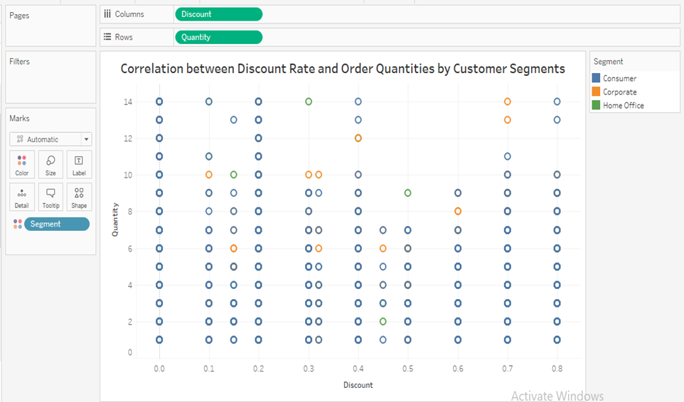

A scatter plot is an effective tool for illustrating the correlation between discount rates and order amounts across different consumer segments. Here’s a refined version of the description:

The scatter plot allows for the visual representation of how discount rates and order amounts correlate across various consumer segments. Each segment is differentiated by color, facilitating easy identification and the observation of unique trends or behaviors within each group.

Analysis of the scatter plot reveals distinct correlations between discount rates and order amounts across different consumer segments:

* Consumer Segment: This segment exhibits the strongest correlation, indicating a higher sensitivity to discounts. Higher discount rates tend to correspond with larger order amounts among consumers.
* Corporate Segment: There is a moderate correlation observed in this segment, suggesting a balanced responsiveness to changes in discount rates. Discounts influence order amounts, but the effect is not as pronounced as in the consumer segment.
* Home Office Segment: This segment shows the weakest correlation, indicating a lower sensitivity to discounts. Purchase decisions in this segment may be influenced by factors other than discounts.

Overall, the scatter plot demonstrates a positive correlation across all consumer segments, implying that higher discounts generally incentivize larger order amounts. This visualization provides valuable insights into the effectiveness of discount strategies across different customer segments, guiding marketing and sales tactics aimed at maximizing order sizes and customer satisfaction.

1. What is the proportion of orders returned in each region within the Superstore dataset?

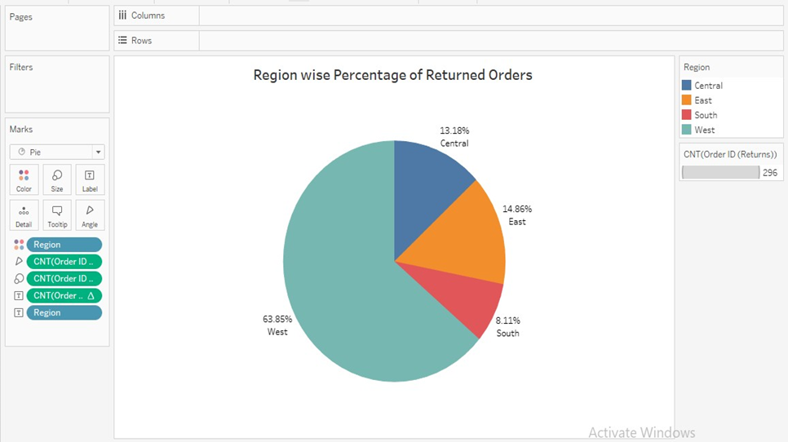

Pie charts are indeed a valuable visualization tool for illustrating the percentage distribution of returned orders across different regions in the Superstore dataset. Here’s a refined version of the description:

Pie charts are effective for presenting the percentage breakdown of returned orders by region in the Superstore dataset, offering an intuitive depiction of parts relative to the whole. This structured format enhances readability and understanding, especially when dealing with a limited number of categories such as geographical regions.

The size of each slice in the pie chart directly communicates the relative magnitude of returns for each region. In this dataset:

* West Region: This represents the largest share of returned orders at 63.85%, indicating a significant portion of returns originate from this area.
* East Region: Follows with 14.86% of returned orders, reflecting a lower but notable percentage compared to the West.
* Central Region: Accounts for 13.18% of returns, indicating a similar proportion to the East.
* South Region: Shows the lowest percentage of returned orders at 8.11%, suggesting the smallest share among all regions.

In summary, the pie chart effectively visualizes the distribution of returned orders across different regions, providing a quick and clear understanding of where return rates are highest and lowest within the Superstore dataset. This visualization aids in identifying regional patterns in returns, informing strategies for improving customer satisfaction and operational efficiency.

1. Can you compare the profit of different products for different subcategories?

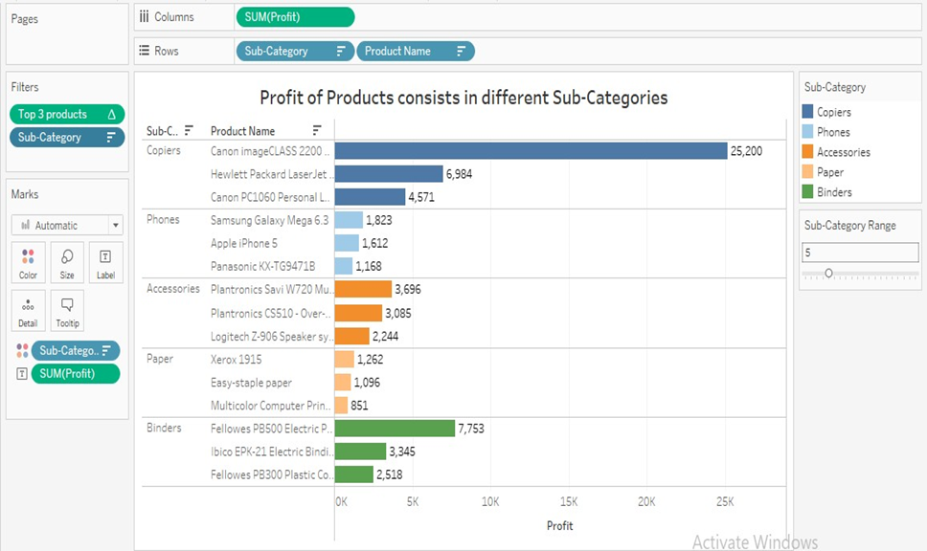

The horizontal bar chart is an excellent choice for comparing product earnings across subcategories due to its logical and organized presentation. Here’s a refined version of the description:

The horizontal bar chart offers a clear and efficient way to compare product earnings within subcategories. Its layout naturally lends itself to displaying profit values, allowing for easy ranking and quick visual assessment. This chart handles longer product names well, as the horizontal orientation accommodates text labels without overcrowding the visualization.

Flexibility in the chart is enhanced by using parameters to adjust the number of visible subcategories, enabling focused analysis on specific groupings as needed. Additionally, employing computed fields to filter and display only the top three profit-generating products helps prevent clutter and emphasizes key insights.

In summary, the horizontal bar chart is a powerful tool for visualizing and analyzing product earnings across subcategories. Its organized layout, clarity in displaying profit values, and flexibility in customization make it an effective choice for understanding profitability trends and identifying top-performing products within each subcategory. This visualization supports informed decision-making and strategic planning in business operations.

1. Which shipping mode is the most commonly used in the Sample Superstore dataset?

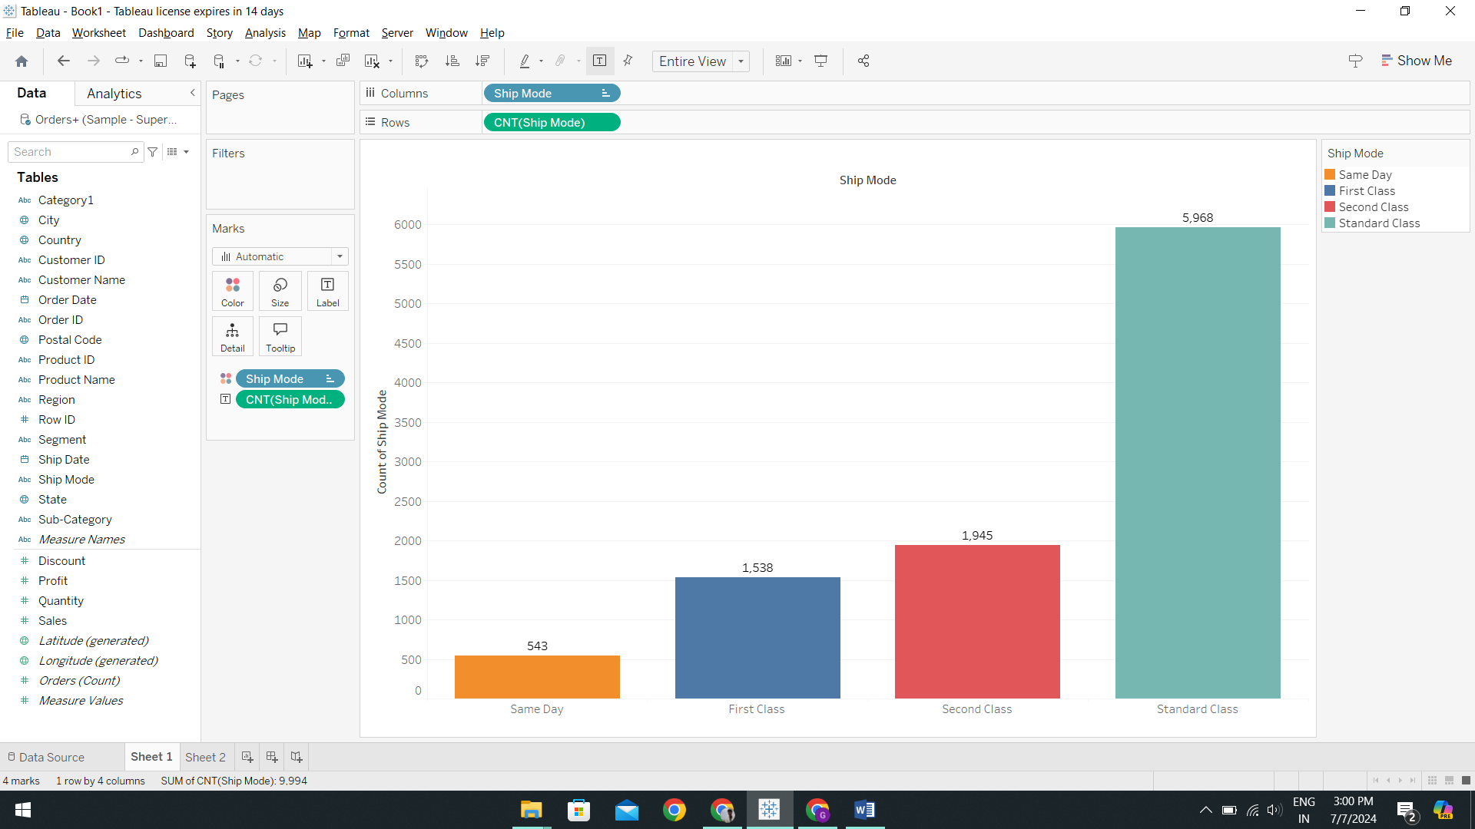

The vertical bar chart effectively represents the popularity of shipping options within the dataset, organized in descending order based on usage. Here’s a refined version of the description:

The vertical bar chart visually arranges shipping modes by their prevalence, with each bar reflecting the frequency of use. 'Standard Class' stands out as the most prominently displayed bar, indicating it is the most widely chosen shipping mode. In contrast, 'Second Class', 'First Class', and 'Same Day' shipping modes appear less frequently.

This graphical representation is particularly effective for quickly highlighting the distribution of shipping categories without requiring detailed numerical interpretation. The substantial size of the 'Standard Class' bar immediately conveys its dominance as the preferred shipping mode within the dataset.

In summary, the vertical bar chart provides a clear and immediate visual impression of shipping mode preferences, emphasizing the significant preference for 'Standard Class' while illustrating the relative popularity of other shipping options. This visualization aids in understanding shipping patterns and can inform logistical decisions related to delivery services and customer expectations.

1. How does the sales performance of different regions evolve throughout the quarters of a year?

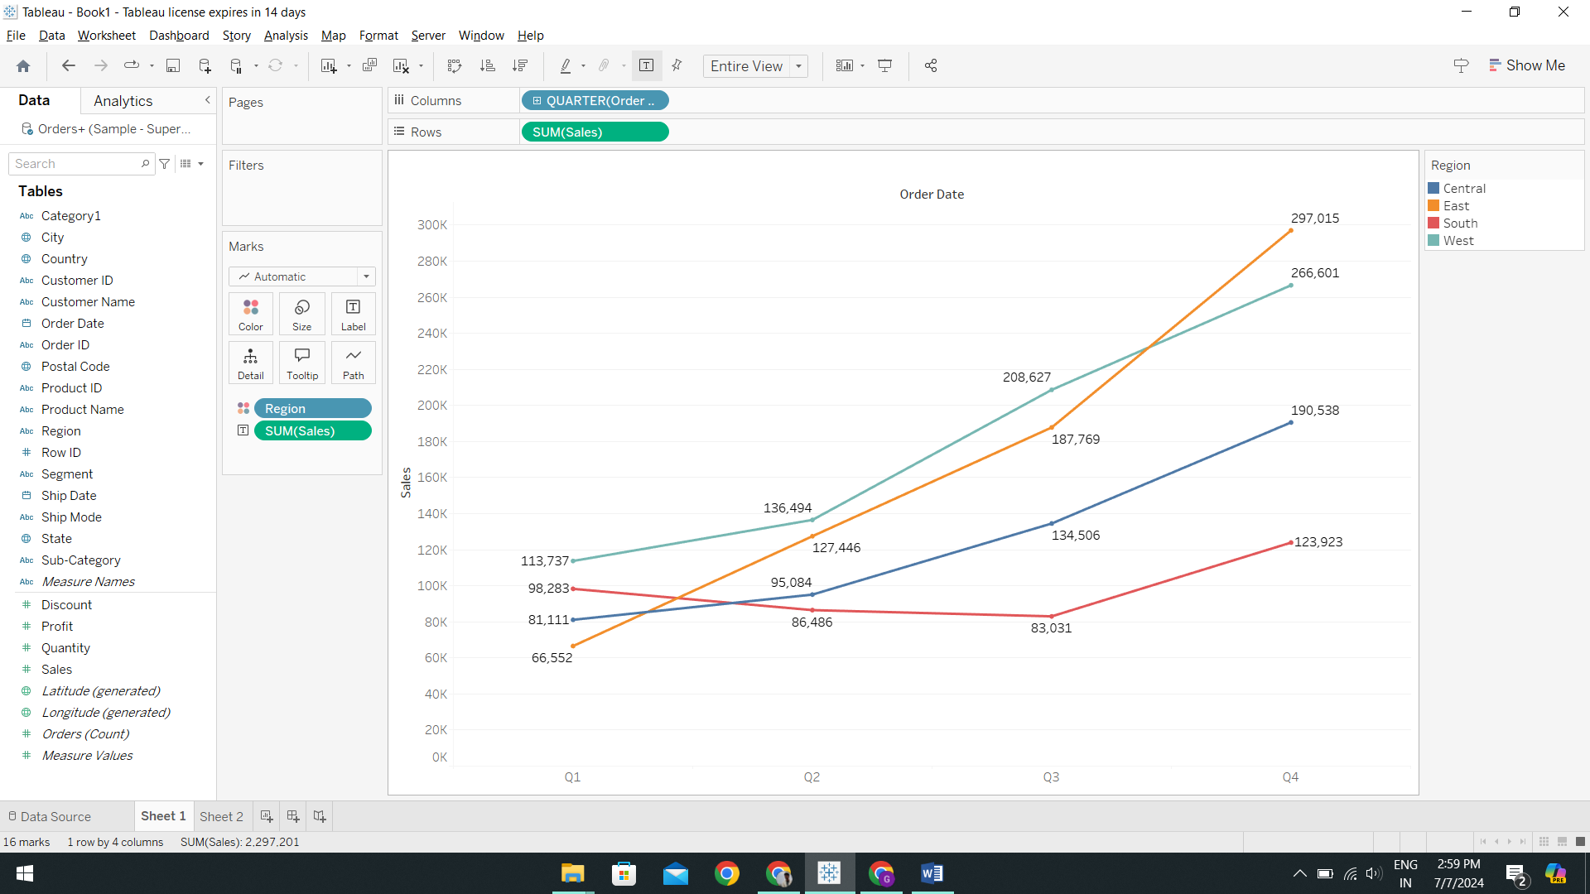

The line chart proves invaluable for visualizing sales performance across various regions throughout the year, particularly by quarter. Here’s a refined version of the description:

The line chart effectively illustrates sales trends across different regions over four quarters in a year. Throughout the year:

* East Region: Demonstrates steady sales growth, culminating in its highest point in the fourth quarter.
* South Region: Shows growth as well, although by the fourth quarter, the Central region slightly outpaces it, leaving the South with the lowest sales for the year.
* Central Region: Exhibits a competitive performance, surpassing the South by the fourth quarter.
* West Region: Maintains a strong start with consistently high sales, finishing just behind the East by the end of the year.

In summary, the line chart displays the quarterly sales patterns across different regions, highlighting trends and relative performance throughout the year. This visualization aids in understanding regional sales dynamics and can inform strategic decisions related to resource allocation, marketing efforts, and sales strategies across diverse geographical areas.

1. What is the distribution of order priorities across different product categories?

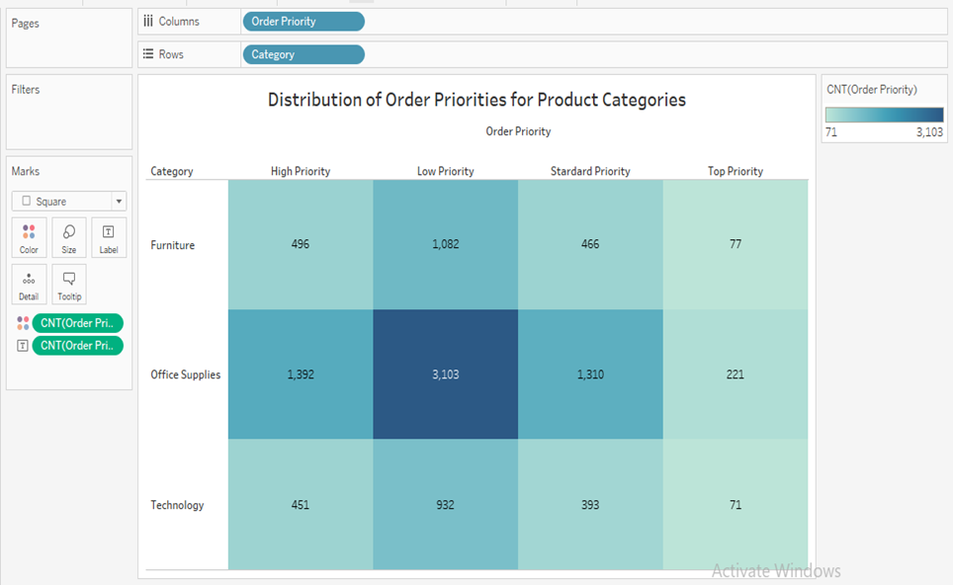

The highlight table chart effectively combines color-coded visuals with the simplicity of a table format, making it an ideal choice for visualizing the distribution of order priorities across various product categories. Here’s a refined version of the description:

The highlight table chart utilizes color coding to enhance the clarity of order priority distribution across different product categories. This format enables quick identification of trends and comparisons between categories and order priorities, as richer color tones indicate higher numbers.

The 'Order Priority' computed field categorizes delivery modes into hierarchical urgency levels: 'First Class' as 'High Priority', 'Second Class' as 'Standard Priority', 'Same Day' as 'Top Priority', and 'Low Priority' for all other shipping modes.

Key insights from the chart:

* Across all product categories, 'Low Priority' is the most frequently chosen delivery option.
* Office Supplies lead in the number of orders, particularly under 'Low Priority', indicating a preference for cost-effective shipping options.
* Across all categories, 'Standard Priority' and 'Top Priority' options are less favored, suggesting a lower demand for faster shipping methods among customers.
* Technology shows the least 'Top Priority' orders, indicating a minimal need for urgent deliveries in this market segment.
* Furniture follows the general trend of preferring 'Low Priority' shipping, though with fewer orders compared to office supplies.

In summary, the highlight table chart effectively communicates the distribution of order priorities across product categories, providing insights into customer preferences for shipping urgency. This visualization aids in understanding logistical preferences and can inform decisions related to inventory management and shipping strategies across different product lines.

1. What is the relationship between discounts and sales?

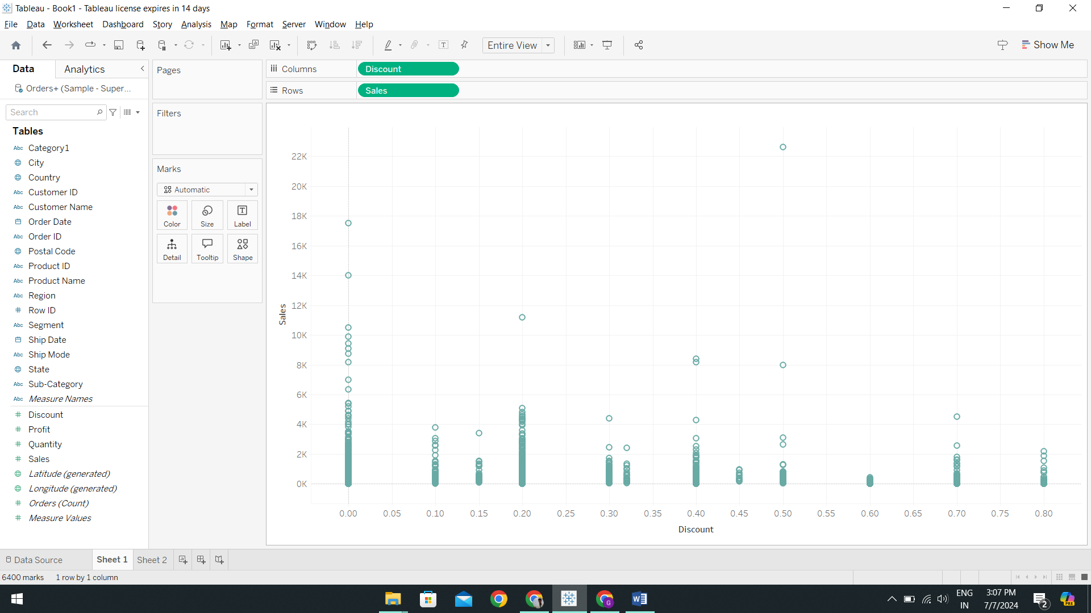

A scatter plot is indeed an excellent choice for visualizing the relationship between two continuous variables such as sales and discounts. Here’s a refined version of the description:

The scatter plot effectively illustrates the distribution and relationship between sales and discounts, offering insights into patterns, outliers, and correlations within the data.

Key observations from the scatter plot:

* Relationship: The plot suggests a varied relationship between sales and discounts. While there are instances of larger sales occurring at lower discount levels, there are also notable sales figures at around a 0.5 discount level. This indicates that even moderate discounts can positively impact sales.
* Impact of Discounts: The scatter plot highlights that significant sales can occur across a range of discount levels, suggesting that substantial discounts may not always be necessary to drive sales.
* Patterns and Outliers: By displaying individual data points, the scatter plot enables the identification of patterns and outliers, providing a comprehensive view of how sales respond to different discount levels.

In summary, the scatter plot is a powerful visualization tool for understanding the nuanced relationship between sales and discounts. It demonstrates that while lower discount levels can attract sales, moderate discounts also play a role in influencing consumer behavior. This visualization supports informed decision-making in pricing strategies and discounting policies, helping businesses optimize their sales performance effectively.

1. How does the average order value differ between repeat customers and new customers?

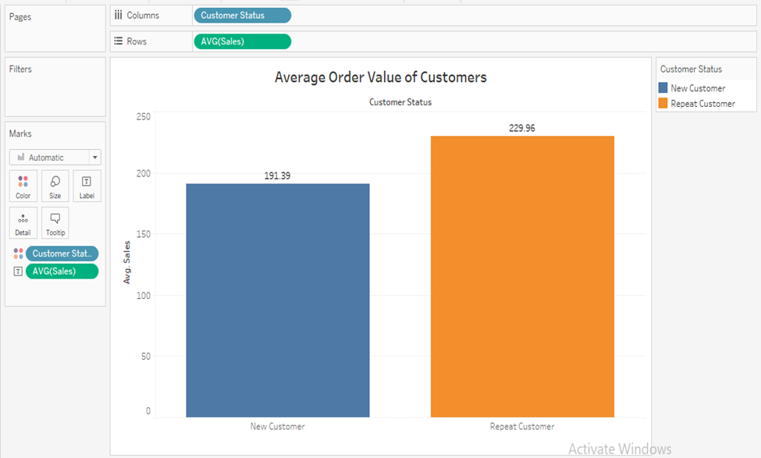

A bar chart is an excellent choice for comparing the average order values between new and returning customers, as it effectively presents data in both quantitative and categorical formats. Here’s a refined version of the description:

The bar chart clearly illustrates the comparison between average order values for new and repeat customers. It demonstrates how bar charts are adept at comparing discrete groups and offering quick visual insights into differences.

The 'Customer Status' computed field categorizes customers based on their order history: 'New Customers' are identified by their first order date, while subsequent orders from the same customer ID are classified as 'Repeat Customers'.

Key insights from the chart:

* Average Order Values: The chart reveals that new customers have an average order value of $191.39, which is lower than the average order value of $229.96 for repeat customers. This suggests that initial purchases tend to be smaller than subsequent orders from returning customers, potentially indicating the effectiveness of marketing incentives or introductory offers in attracting new buyers.
* Visual Comparison: By visually comparing the bar heights for 'New Customers' and 'Repeat Customers', the chart provides an immediate understanding of the difference in average order values between these customer groups.

In summary, the bar chart effectively communicates the difference in average order values between new and repeat customers, highlighting insights into consumer behavior and the potential impact of marketing strategies on purchase patterns. This visualization supports strategic decision-making to optimize customer acquisition and retention efforts based on observed purchasing trends.

1. What is the geographical distribution of returns and its impact on overall profitability?

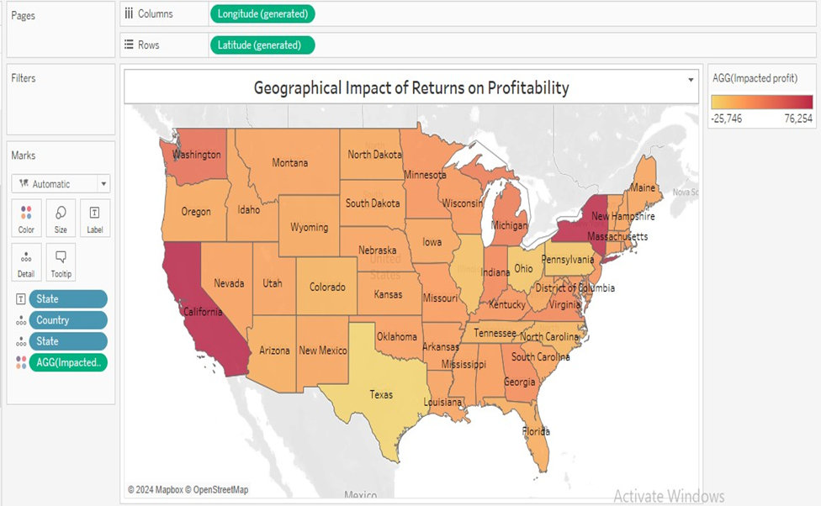

A map chart is indeed an excellent choice for visualizing the regional distribution of returns and their impact on profitability, providing a spatial context that stakeholders can easily understand. Here’s a refined version of the description:

The map chart effectively illustrates how returns impact profitability across different regions, leveraging spatial context to show geographical relationships with financial performance. Color gradients enhance clarity by indicating varying levels of profit impact.

Key observations from the map chart:

* Return Impact on Profit: The chart uses the 'Return Impact on Profit' field to depict the precise financial impact of returns, distinguishing between profit and losses resulting from returned products.
* Regional Analysis: The map reveals that, aside from New York and Virginia, regions in the northern and western United States experience larger impacts from returns, indicating potentially higher return rates or larger financial losses in these areas.
* Spatial Context: By using a map format, the visualization allows stakeholders to quickly identify regions requiring closer attention due to significant return impacts, fostering strategic decisions and targeted interventions.

In summary, the map chart is a powerful tool for visually mapping the geographical distribution of return impacts on profitability. It enables stakeholders to grasp regional trends and disparities in financial performance related to returns, facilitating informed decision-making and proactive management of operational challenges across different areas.

—--------------Thank You—-------------